# Homework: Operating Systems

## Work with Task Manager in Windows

1. **View processes:**
   * Open Task Manager and view the list of running processes.
   * Identify any processes that are using a high amount of CPU or RAM.

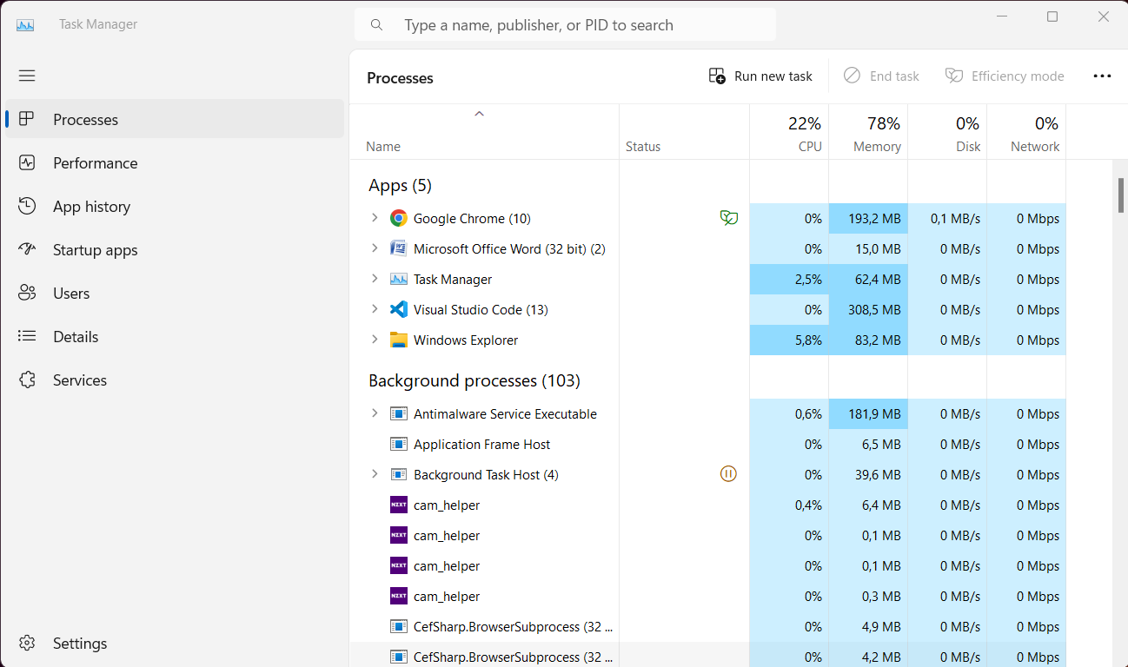

1. **Kill a process:**
   * Select a process from the list and end the task.

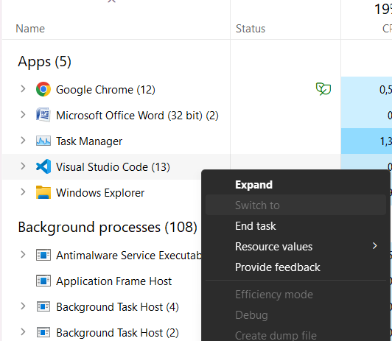

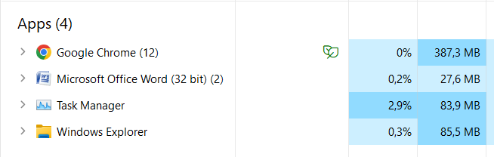

1. **View CPU & RAM usage:**
   * Navigate to the Performance tab in Task Manager and view the CPU & Memory usage.

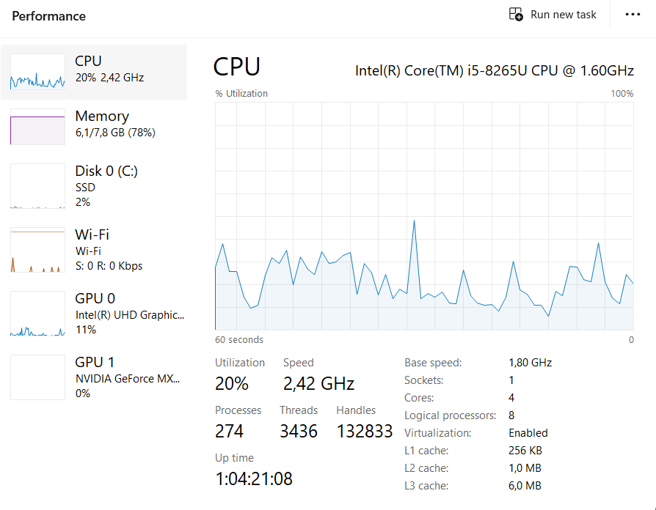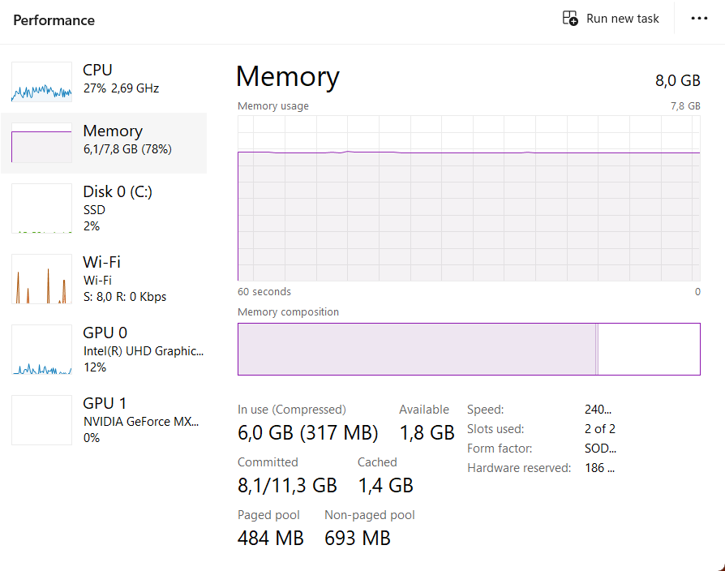

## Play with Windows Terminal

1. **Navigate Directories:**
   * Use the "**cd**" command to navigate to different directories in the Windows Terminal:
     + Desktop

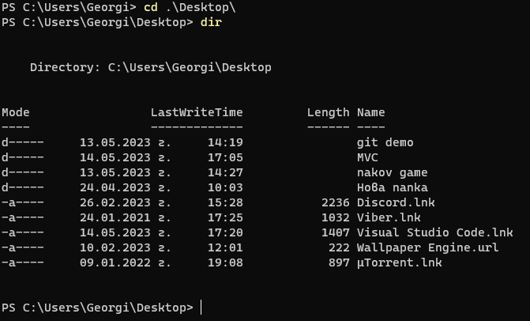

* + - Documents

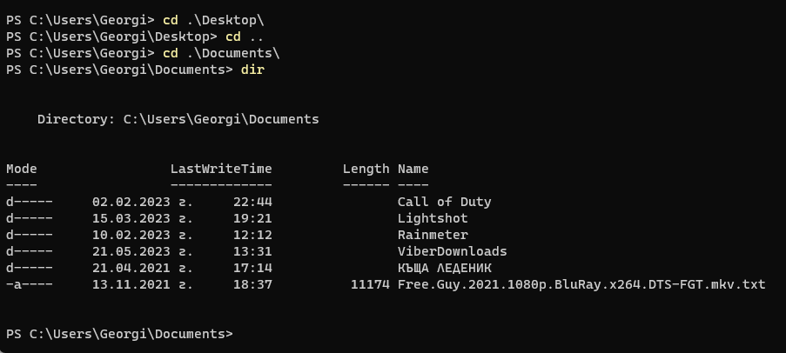

* + - Downloads

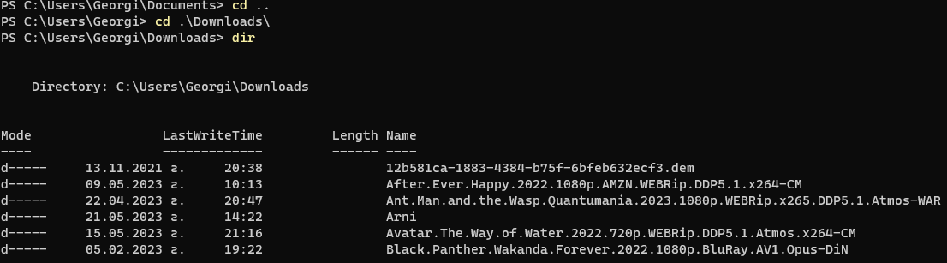

* + Create folder named My_SoftUni_Repo on the Desktop through the Terminal.

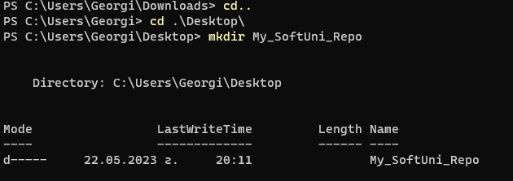

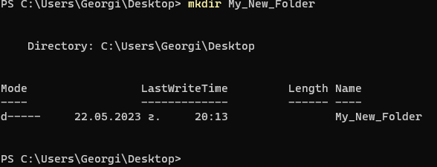



* + Enter the created folder through the Terminal and make a screenshot:



## Play with Docker Playground & Run a Linux Shell inside

1. **Run your own container in Docker Playground and make an HTTP request from Linux Shell:**

